

Appeal filed in connection with proposed landfill expansion in Gardner
- 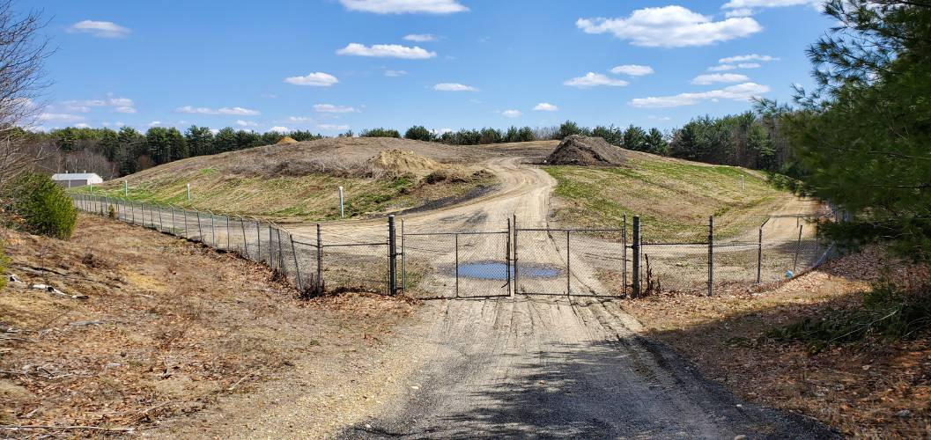
The wastewater sludge landfill in West Gardner. FILE PHOTO

By GREG VINE
For the Athol Daily News
Published: 12/21/2022 3:05:31 PM
Modified: 12/21/2022 3:02:46 PM
GARDNER — In mid-November, Gardner’s Conservation Commission signed off on the city’s Notice of Intent to greatly expand its wastewater sludge landfill, located in West Gardner, at the same time issuing several conditions for the expansion to move forward. The NOI was submitted by the city’s engineering consultant, Woodward & Curran.
Now, an appeal has been filed by Attorney Nathanial Stevens of the Boston law firm McGregor Legere & Stevens on behalf of a dozen Chair City residents asking the state Department of Environmental Protection to “issue a Superseding Order of Conditions blocking any work on the expansion.”
The Athol Daily News reached out to Gardner Conservation Agent Sophie Dorow, who said she needed to speak to other officials, including ConCom members, before the city provides a response to the appeal.
Much of the appeal appears to be based on the alleged failure of the commission to take into account a number of concerns raised in a peer review of the city’s plan conducted by the engineering firm Tighe & Bond. In the cover letter accompanying the formal appeal, Stevens writes: “Tighe & Bond outlined a number of areas where information was lacking and recommended that the Commission request the Applicant to undertake additional field work and calculation as well as provide further information.”
Tighe & Bond subsequently sent two additional letters reiterating its concerns about the project but, wrote Stevens, “The full Commission spent a short amount of time considering Tighe & Bond’s comments at its November 14, 2022 meeting before closing the hearing and voting to approve the Project.”
“Tighe & Bond provided a letter to the commission suggesting that the commission require that the city, the DPW, do some additional work to demonstrate that this project would meet performance standards under the Wetlands Protection Act,” Stevens told the Athol Daily News. “The commission essentially ignored most, if not all, of those (suggestions), and just seemed to be in a hurry to approve it. Many conservation commissions feel the pressure when their own municipality is proposing a big public works project. They probably felt some pressure and just went ahead and ignored their own peer reviewer and approved the project.”
Stevens also claimed the commission had failed to take into account the proximity of the expansion to nearby wetlands.
“The work is close to the buffer zone,” he said, “and then there’s an additional issue with an existing drainage problem from the landfill, which the commission seemed to not want to address.”
The existing landfill, as well as the area proposed for expansion, lies about a mile from an area designated as an Environmental Justice Population. According to the U.S. Dept. of Agriculture, such an area is defined as a neighborhood where the annual median household income is equal to or less than 65 percent of the statewide median, or whose population is made up 25 percent minority, foreign born, or individuals lacking proficiency in the English language. Gardner’s EJP was determined solely on income.
“These populations are nearby,” said Stevens, “and this is just exacerbating the historical environmental justice issues here, that these types of facilities should be located in or near such populations.”
In addition, the Notice of Intent submitted by Woodward & Curran failed, according to the appeal, to examine alternatives to expansion, including a consideration of partnering with neighboring communities or pursuit of a private sector partnership to find a viable alternative to the project.
“The NOI alternatives analysis dismisses…alternatives without completing a single feasibility study of any such alternative,” ,” Stevens writes in the appeal. “In addition, the city has rejected pursuit of a phased construction of the project which will, in effect, commit the City to the 17-year landfill expansion. This effectively (means) Gardner will not be able to take advantage of innovation in other alternatives or partner with other communities in pursuit of a sustainable solution prior to 2042.”
Stevens explained that the city is not required to respond to the appeal, which DEP may take several months to decide. He added that DEP would likely schedule a site visit to take place sometime after the first of the year, after which the staff will make a recommendation on the appeal.”
“The regional office will then issue a superseding order,” he explained, “which will either reverse the commission’s decision, affirm the commission’s decision, or they could write their own conditions.”
The city wants to expand the existing sludge landfill from six to 10.3 acres. A coalition fighting expansion argues the larger landfill would endanger more than 70 private wells in Gardner and Templeton, while leaching pollutants in the Otter River, a tributary of the Millers River.
The Coalition for a Sustainable Alternative to the Gardner Sludge Landfill Expansion includes several Athol-based organizations, including the Athol Bird and Nature Club, the Millers River Watershed Council, and the Mount Grace Land Conservation Trust, in addition to Clean Water Action, the Connecticut River Conservancy, Gardner Clean Air, MassPIRG, the Massachusetts Rivers Alliance, and the North County Land Trust. It receives technical support from the Sierra Club.
Greg Vine can be reached at gvineadn@gmail.com.

